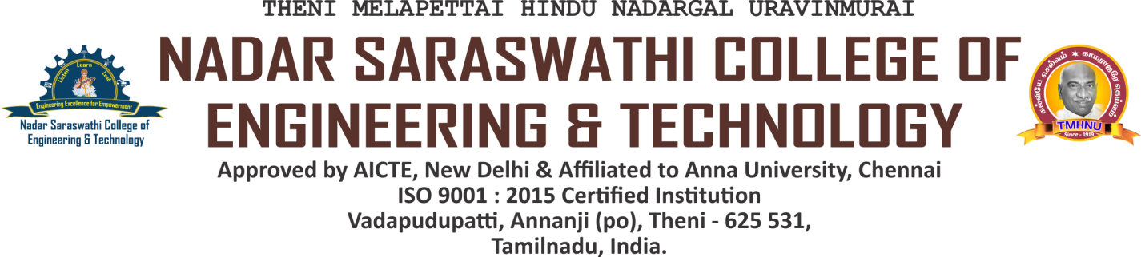

Reports of the Audits

| **S.No** | **Parameter** | **Link** |
| --- | --- | --- |
| **1** | A. Green & Environment Audit Report | [VIEW](https://nscet.org/ssr/dvv-clarification/c7/7.1.3/3.a.Green%20-and-Environment%20-Audit%20Report.pdf) |
| B. Energy Audit Report | [VIEW](https://nscet.org/ssr/dvv-clarification/c7/7.1.3/3.b.Energy-Audit-Report%20(1).pdf) |